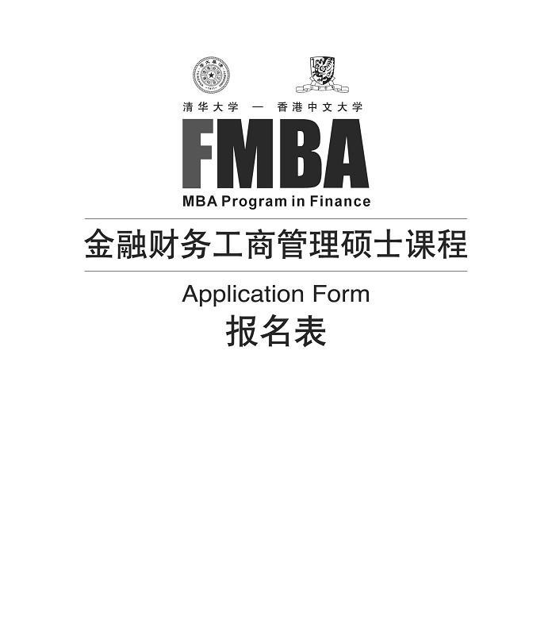
2016
报名须知/ Notes for Applicants

为了使您的报名有效，请您如实填写报名表，并按要求提供所需文件，我们承诺对您所提供的信息严格保密。
※
※
您可通过在线报名系统提交申请：http://www.sem.tsinghua.edu.cn/fmba/
1. 报名表
此申请表必须由申请人填写，各项填写内容要求完整清晰，并保证所填内容属实。如经核实发现造假行为，将取消报名资格。
报名表的第I、II部分（个人信息、目前工作单位）请用中英文双语填写，其他部分（包括推荐信）可使用中文或者英文填写。
2. 两封推荐信
推荐人须充分了解申请人的学术成就和工作业绩等情况。推荐人之一最好是申请人的直接领导，另一位推荐人可以是了解申请人的权威人士。推荐信须由推荐人本人填写并签名，放入信封内，并在封口处签名，由申请人提交。推荐信由招生考试委员会拆封，未密封的推荐信无效。
3. 证书
学历、学位证书的复印件各两份，具有多个学历学位的，应同时提供相关材料；英语成绩单[CET6/TEM8/PETS5/ GMAT(Verbal)/TOEFL/IELTS任一即可]需提交原件，其中GMAT(Verbal)/TOEFL/IELTS成绩单须由相关机构直接寄到香港办公室，工作年限超过七年或毕业于以英语为母语的国家的院校者，可获豁免此要求。
4. 附件
- 两张二寸照片（请提供半年以内的照片，并用铅笔在背面署名），其中一张按要求贴在报名表上。
- 身份证、护照（如有）复印件一份，按要求贴在报名表上。
- 两张名片，其中一张按要求贴在报名表上。
- 目前所在工作单位简介（中英文各一份）。
- 两份完整的大学成绩单原件，必须加盖学校公章（须学校教务处或档案馆公章，院系公章无效），如已获硕士或博士学位，也请提供相应的成绩单。成绩单需密封，并在密封口处盖章。学历在境外或港澳台获得的，成绩单需由毕业院校直接寄至香港中文大学金融财务MBA办公室。持有香港中文大学学位者，只需提交成绩单复印件。
- 报名费交付凭证复印件一份。

Please provide accurate information on the application form. All information provided will be treated as strictly confidential.
Application may be submitted through our online system at http://www.sem.tsinghua.edu.cn/fmba/
1. Application Form
The application form must be completed by the applicant. The information that is given in support of this application must be accurate and true. Any misrepresentation will result in disqualification of the application for admission.
Parts I and II of the form (Personal Information, Current Employer) must be completed in BOTH English and Chinese. Other parts and the recommendation letters can be completed either in English or Chinese.
2. Two Letters of Recommendation
Referees should be individuals who know your abilities and personalities, professionally or academically. One of them should be your current immediate supervisor, and the other be an authoritative person who knows you well. Each recommendation letter should be filled in and signed by the referee, and placed in a sealed envelope. Applicants should submit the recommendation letters together with other application materials. The recommendation letters will be opened by the Admissions Selection Committee. Any recommendation letter provided in an unsealed envelope will be invalid.
3. Certificates
Two copies of each of the degree and graduation certificates. If you have acquired more than one degree, please also provide the relevant certificates. One of the official English certificates (CET6/TEM8/PETS5/GMAT(Verbal)/TOEFL/IELTS) that you have attained. The original score report of GMAT(Verbal)/
TOEFL/IELTS must be sent directly from the test institutions concerned to the program office of The Chinese University of Hong Kong. For applicants who have seven or more years of work experience, or who have a degree from a university in an
English-speaking country, an English certificate is not a compulsory.
4. Attachments
1) Two recent photographs (2〞×2〞) with your name printed on the back in pencil, one of which should be affixed to the application form.
2) One copy of your ID card and passport (if any), which should be affixed to the application form.
3) Two business cards, one of which should be affixed to the application form.
4) One copy of your current company's introduction in both Chinese and English.
5) Two copies of official transcripts sealed with the official stamp of the university you attended (only Academic Administration office or Archive are accepted). Transcripts should be sealed in an envelope with official stamp of the university on it. If you have obtained a master's or doctoral degree, please also provide the relevant transcripts. If you obtained your diploma/certificates abroad or in Hong Kong/
Macau/Taiwan, the transcripts should be sent directly from the university to the program office in Hong Kong. Applicants holding CUHK qualifications at the bachelor’s level or above may submit only photocopies of their transcripts.
6) One copy of pay-in-slip of the application fee.

金融财务工商管理硕士课程报名表
MBA Program in Finance Application Form

请选择报读班级 □ 2016年北京班 □ 2016年深圳班
Please choose the class you are applying for □ 2016 Beijing Class □ 2016 Shenzhen Class
Please affix a recent
2〞×2〞photo
请贴二寸近照

Please affix a copy of your ID card
请贴上清晰的身份证复印件

Please affix a business card
请贴上一张名片

Please affix a copy of your passport (the page with your photo and personal data)
请贴上清晰的护照 (含照片及个人资料)复印件

I 个人信息
姓 名 拼 音 性 别 □男 □女
出生日期 年 月 日 工作年限
身份证号
护照号
国 籍 出 生 地 户 籍
住宅地址 省 市
电 话 手 机
传 真 常用信箱
通信地址 省 市
邮 编
请您指定一位紧急联系人 （先生/女士）
电话/手机 电子信箱

I Personal Information
Title □Mr. □Ms.
Last Name（Surname）
First Name
Identification Card Number
Nationality Passport No.
Place of Birth Hukou
Date of Birth （dd/mm/yy） Years of Work Experience
Home Address
Home Phone No.
Cell Phone No.
Fax No.
E-mail Address
Postal Address
In case of emergency, please contact □Mr.□Ms. at Phone No.
E-mail Address

Ⅱ 目前工作单位 (带※号的为选填内容)
单位名称
是否为上市公司 □是 □否
职务 担任此职务年限
※
目前年薪 元（人民币）
公司或单位员工人数 您下属员工人数
※
公司总资产 元（人民币）
※
年度销售额 元（人民币）
单位地址
单位邮编
单位电话 单位传真
请标明贵单位的行业类别
□银行 □证券 □保险 □投资
□房地产 □IT、电信 □高科技 □政府
□媒体、广告 □咨询业、法律 □其他
请标明贵单位的性质
□政府机关/非盈利机构 □国有企业 □外商独资，请注明外方所属国别/地区
□集体 □民营 □中外合资，请注明外方所属国别/地区
□其他
Ⅱ Current Employer (※ not a required field)
Company name
Is your company listed？ □Yes □No
Position or title Years of service in your current position
Current salary Yuan（RMB）
Number of employees in your company Number of subordinates under your supervision
Total assets of your company Yuan（RMB）
Annual sales of your company Yuan（RMB）
Business Address
Office Phone No. Office Fax No.
Which industry are you currently working in？
□Banking □Security □Insurance
□Investment □Real Estate □IT/Telecommunications
□High-tech □Government □Media/Advertising
□Consulting/Law □Other
What kind of enterprise are you working for？
- Government/Non-profit organization □State owned □Collectively owned
- Wholly foreign owned: please specify country/region _____________ □Privately owned
- Joint venture: please specify country/region __________________ □Other __________________

※
※
※

Ⅲ 工作背景
Ⅲ Work Experience
请在下面的空格中详细写明您所从事过的所有工作，须明确每项工作的从事时间、职务，并简述担任该职务时的工作内容（从最近的工作开始，时间请注明月份）。
In the space provided below, list all of your professional experience. Please indicate clearly the period, position and a brief description of the job(s). Please list your current job first.

时 间（年/月）  Period (Month/Year) | 公司名称  Company | 职 务  Position
从(From) ＿＿＿＿＿
至(to) ＿＿＿＿＿
主要职责与主要成就
Main Responsibilities
and
Major Achievements
从(From) ＿＿＿＿＿
至(to) ＿＿＿＿＿
主要职责与主要成就
Main Responsibilities
and
Major Achievements
从(From) ＿＿＿＿＿
至(to) ＿＿＿＿＿
主要职责与主要成就
Main Responsibilities
and
Major Achievements
从(From) ＿＿＿＿＿
至(to) ＿＿＿＿＿
主要职责与主要成就
Main Responsibilities
and
Major Achievements
从(From) ＿＿＿＿＿
至(to) ＿＿＿＿＿
主要职责与主要成就
Main Responsibilities
and
Major Achievements
从(From) ＿＿＿＿＿
至(to) ＿＿＿＿＿
主要职责与主要成就
Main Responsibilities
and
Major Achievements
从(From) ＿＿＿＿＿
至(to) ＿＿＿＿＿
主要职责与主要成就
Main Responsibilities
and
Major Achievements
从(From) ＿＿＿＿＿
至(to) ＿＿＿＿＿
主要职责与主要成就
Main Responsibilities
and
Major Achievements

Ⅳ 教育背景（从最高学位起始）
Ⅳ Education（please list your highest degree first）

学校  Institution | 专业  Major | 学位 (如经济学学士等)  Degree Attained (e.g. Bachelor of Economics, etc.) | 学历（如本科、硕士等）  Qualification (e.g. bachelor, master, etc.) | 学习模式 (如全日、兼读、远程、网络等)  Mode of Study (e.g. Full-time, Part-time, Distance Learning, Internet, etc.) | 上课地点 (如北京、深圳、香港、美国等)  Location of Study (e.g. Beijing, Shenzhen, Hong Kong, USA, etc.) | 起止时间（年/月）  Periods(Month/Year)
从(From)＿＿＿＿
至(to) ＿＿＿＿
从(From)＿＿＿＿
至(to) ＿＿＿＿
从(From)＿＿＿＿
至(to) ＿＿＿＿
从(From)＿＿＿＿
至(to) ＿＿＿＿
Ⅴ 请您回答以下问题
Ⅴ Please answer the following questions

1．请阐述您目前工作单位的性质，您主要的工作职责，以及您在其中起到的领导作用，并提供本单位的组织架构图。
Please specify the nature of your company’s business, your main job responsibilities, and your leading role in the current job position. Please also provide your company organizational chart.

2．请用五句话描述您的个人特点.
Please state your personal characteristics/self-assessment in five sentences.

3．请阐述您取得的重要成就，以及您在其中发挥的管理才能。
Please state your major achievements and your managerial capabilities in achieving them.

4．请阐述您的职业发展目标。您希望攻读清华大学-香港中文大学金融财务MBA项目对您达到这些目标有怎样的推动作用？
Please state your career goals. How can the Tsinghua-CUHK Finance MBA program help you to achieve these goals?

Ⅵ 奖学金
Ⅵ Scholarship
您是否申请奖学金？如果是，请提供一封自述及本人签名约1500字的中文申请信，并手写签名。
Would you like to apply for a scholarship? If yes, please submit a formal duly signed application letter of approximately 1500 words in Chinese. □是 Yes □否 No
招生录取委员会将根据申请人提供的材料及面试成绩进行评定。
The assessment will be based on the application materials and interview performance. The final decision will be made by the Admissions Selection Committee.

奖学金申请者条件：
1.事业上已经取得成就，对企业、社会或国家有过突出贡献；
2.具有优秀的领导者素质和潜力；
3.愿意致力于组织的变革和发展, 有进取心。
Who is eligible to apply?
Applicants should:
1. have made outstanding contributions to their organization, society or nation;
2. have great potential or good leadership;
3. have strong commitment to the reform and development of their organization and be aggressive in their work.

奖学金为非现金形式，得奖者将获得部分学费减免。
Successful applicants will receive a subsidy of part of the tuition fee, which is not payable in cash.

Ⅶ 附加信息（仅供办公室内部使用）
Ⅶ Additional Information（Information collected is for office use only）
◆您第一次是从哪个渠道听说本项目的？
Where did you first learn about this program?
□报纸Newspaper 请列出报纸名称Please specify ____________________
□杂志Magazine 请列出杂志名称Please specify ____________________
□网站Website 请列出网站名称Please specify ____________________
□同事或朋友推荐 Colleague or friend
□贵公司人力资源部 Human Resources Department of your organization
◆您是否同时在申请其他院校的课程？如果是，请列出院校和课程名称。
Are you concurrently applying for other programs?
□否 No □是 Yes
请列出院校/课程名称Please specify School/Program _______________________________________
Ⅷ 申请人声明
Ⅷ Declaration
1、我保证此申请表由我本人填写，一切信息属实。如经核实发现造假行为，将被取消报名和入学资格。我知道报名材料中的虚假、错误或重大遗漏会导致不录取或取消学籍。我理解并同意所有报名材料归学院所有，无论是否录取均不退回。
I declare that the information given in support of this application is accurate and complete, and understand that any misrepresentation will result in the disqualification of my application for admission and subsequent enrolment in the university. I understand that the application materials that I submit will NOT be returned to me regardless of my acceptance into this program.

2、本人授权香港中文大学及清华大学使用本人的个人资料，用以查询有关入学申请及本人在大学或其他学术机构的就读资料及考试成绩。
I authorize The Chinese University of Hong Kong and Tsinghua University to use my personal data for verifying information about my public examination results and academic record in relevant institutions in China, Hong Kong and elsewhere.

3、本人明白在注册后，有关资料将转作学生记录，而该记录将用于与本人学业相关的一切事宜，并可于去除学生个人资料后，将数据用作统计或行政上的参考。
I understand that upon registration, the relevant data will become part of my student record which will be used for all purposes relating to my studies in accordance with the procedures of the University. The data will also be used for statistical and administrative purposes and in such circumstances, personal identifiers will be removed.

签名Signature 日期Date
申请者提交材料后，我们将根据以下各项核查所寄材料是否齐全。(下表仅供办公室使用)
Checklist (for office use only)
报名表 |  | Application form
一份身份证复印件（贴在报名表上） |  | One copy of your ID card (affixed to the application form)
一份护照复印件（如有，贴在报名表上） |  | One copy of your passport, if any (affixed to the application form)
两份大学成绩单 |  | Two copies of full official transcripts
两份学位、学历复印件 |  | Two copies of degree certificates / diploma
一份英语证书原件(CET6/TEM8/PETS5/  GMAT(Verbal)/TOEFL/IELTS) |  | One of the official English certificates( CET6/TEM8/PETS5/  GMAT(Verbal)/TOEFL/IELTS )
两封推荐信 |  | Two recommendation letters
两张二寸近照（一张贴在报名表上） |  | Two recent photos (2〞×2〞) (one affixed to the application form)
两张名片（一张贴在报名表上） |  | Two business cards (one affixed to the application form)
工作单位简介(中英文各一份) |  | One copy of your current company’s introduction in both English and Chinese
奖学金申请材料（如若申请需提交） |  | Application materials for scholarship (if any)
报名费 |  | Application fee
□汇款 □转账 □现金 □支票 |  | □Remittance □Bank transfer □Cash □Cheque

推荐信（清华大学-香港中文大学金融财务MBA项目）
推荐人姓名： 被推荐人姓名：

致推荐人：
推荐人的意见也是评估申请人不可缺少的一部份，请您认真填写。
以下信息，如果您有其它补充的内容，请随信附上。请您完成推荐信后，附上名片，将此推荐信放入信封，在封口处签名并交还申请人，由申请人将此信和其他报名材料一起寄回金融财务MBA办公室。十分感谢您填写此推荐信，我们收到推荐信后，将可能与您联系，进一步核实推荐信的内容。

1．您与申请人相识多久和关系？

2．请描述申请人现在的工作职责。

3．您认为申请人报考的最大愿望是什么，以及您认为申请人最适合的发展前途是什么？

4．您认为申请人最需要改进的方面是什么？

5．您对申请人的简要评价。

6．您对申请人相关能力的评价表
 | 突出  (高于5%) | 极好  (高于10%) | 好  (高于15%) | 平均  (高于35%) | 低于平均(低于35%) | 不能判断
英语口语能力
英语写作能力
定量分析能力
解决问题能力
人际关系能力
创造力
成熟度
正直、诚实
工作热情
领导能力

单位名称：

请贴上一张名片

职 务：
联系电话：
地 址：
电子信箱：
签 名：
日 期：

Letter of Reference (Tsinghua-CUHK MBA Program in Finance)
Name of Applicant (English) Name of Referee (English)

(Chinese) (Chinese)
To the referee:
Recommendation letters are crucial to the applicant and should be completed thoroughly. If you need to use additional sheets, please attach them to the form. When completed, please attach a business card, sign your name across the seal on the envelope flap, and return it to the applicant. It is the applicant’s responsibility to enclose the letter in the completed application package and send it to the FMBA office. We greatly appreciate your time and effort in completing this form. We may contact you for further information and confirmation.

1. How long and in what capacity have you known the applicant?

2. Please describe the applicant’s current job responsibilities.

3. In your opinion, what is the applicant’s major objective in taking this program and potential for career development?

4. Which area is the applicant most in need of improvement?

5. Please give a brief assessment of the applicant.

6. Please evaluate other aspects of the applicant as follows.
 | Outstanding  Top5% | Excellent  Top10% | Good  Top15% | Average  Mid35% | Below  Average  Bottom35% | No Basis for Judgment
Oral English Skill
Written English Ability
Analytical/Quantitative Ability
Problem-Solving Skills
Interpersonal Skills
Creativity
Maturity
Integrity
Motivation
Leadership Potential

Company

Please affix a business card

Position or Title
Phone
Address
E-mail
Signature
Date

推荐信（清华大学-香港中文大学金融财务MBA项目）
推荐人姓名： 被推荐人姓名：

致推荐人：
推荐人的意见也是评估申请人不可缺少的一部份，请您认真填写。
以下信息，如果您有其它补充的内容，请随信附上。请您完成推荐信后，附上名片，将此推荐信放入信封，在封口处签名并交还申请人，由申请人将此信和其他报名材料一起寄回金融财务MBA办公室。十分感谢您填写此推荐信，我们收到推荐信后，将可能与您联系，进一步核实推荐信的内容。

1．您与申请人相识多久和关系?

2．请描述申请人现在的工作职责。

3．您认为申请人报考的最大愿望是什么，以及您认为申请人最适合的发展前途是什么？

4．您认为申请人最需要改进的方面是什么？

5．您对申请人的简要评价。

6．您对申请人相关能力的评价表
 | 突出  (高于5%) | 极好  (高于10%) | 好  (高于15%) | 平均  (高于35%) | 低于平均(低于35%) | 不能判断
英语口语能力
英语写作能力
定量分析能力
解决问题能力
人际关系能力
创造力
成熟度
正直、诚实
工作热情
领导能力

单位名称：

请贴上一张名片

职 务：
联系电话：
地 址：
电子信箱：
签 名：
日 期：

Letter of Reference (Tsinghua-CUHK MBA Program in Finance)
Name of Applicant (English) Name of Referee (English)

(Chinese) (Chinese)
To the referee:
Recommendation letters are crucial to the applicant and should be completed thoroughly. If you need to use additional sheets, please attach them to the form. When completed, please attach a business card, sign your name across the seal on the envelope flap, and return it to the applicant. It is the applicant’s responsibility to enclose the letter in the completed application package and send it to the FMBA office. We greatly appreciate your time and effort in completing this form. We may contact you for further information and confirmation.

1. How long and in what capacity have you known the applicant?

2. Please describe the applicant’s current job responsibilities.

3. In your opinion, what is the applicant’s major objective in taking this program and potential for career development?

4. Which area is the applicant most in need of improvement?

5. Please give a brief assessment of the applicant.

6. Please evaluate other aspects of the applicant as follows.
 | Outstanding  Top5% | Excellent  Top10% | Good  Top15% | Average  Mid35% | Below  Average  Bottom35% | No Basis for Judgment
Oral English Skill
Written English Ability
Analytical/Quantitative Ability
Problem-Solving Skills
Interpersonal Skills
Creativity
Maturity
Integrity
Motivation
Leadership Potential

Company

Please affix a business card

Position or Title
Phone
Address
E-mail
Signature
Date

报名费Application Fee：
请在提交报名表的同时，缴纳报名费人民币100元，如电汇，请汇至以下账户：
Please remit the application fee of RMB 100 to the following account:
北京：
户 名：清华大学
开户行：工行北京分行海淀西区支行
账 号：020 0004 5090 8913 1550
深圳：
户 名：清华大学深圳研究生院
开户行：平安银行深圳华新支行
账 号：0142100324889

香港：
香港申请人请将报名表及报名费（划线支票：HK$120 台头：香港中文大学）
寄至以下地址：
香港新界沙田
泽祥街12号
香港中文大学郑裕彤楼7楼743室
金融财务工商管理硕士课程办公室

Hong Kong:
Hong Kong applicants should send the completed application form
together with a crossed cheque in the amount of HK$120 payable to
"The Chinese University of Hong Kong" to the following address:

MBA in Finance
The Chinese University of Hong Kong
Room743, 7/F, Cheng Yu Tung Building, No.12, Chak Cheung Street, Shatin, N.T., Hong Kong

联系方式：

北京：
地址：北京市清华大学经管学院伟伦楼241室 邮编：100084
电话：(86-10) 62789683 62793962 62794227
联系人：李老师 王老师 孟老师 电子信箱：finmba@sem.tsinghua.edu.cn
网址：http://www.sem.tsinghua.edu.cn/fmba

深圳：
地址：深圳市南山区西丽大学城清华校区B栋201室 邮编：518055
电话：(86-755) 26032690 26036876 26036954 传真：(86-755) 26036887
联系人：吴老师 曹老师 陈老师 电子信箱：finmba@sz.tsinghua.edu.cn
网址：http://www.sz.tsinghua.edu.cn/

香港：
地址：香港新界沙田泽祥街12号 香港中文大学郑裕彤楼7楼743室 金融财务MBA办公室
电话：(852) 39437896 39437795 39435980 传真：(852) 26037871
联系人：伍老师 余老师 陈老师 电子信箱：finmba@cuhk.edu.hk
网址：http://www.bschool.cuhk.edu.hk/mbafin

Contact us:
MBA in Finance, School of Economics and Management, Tsinghua University
Address | Room 241, Wei Lun Building, Beijing
P. C. | 100084
Tel | (86-10) 62789683 62793962 62794227
Email | finmba@sem.tsinghua.edu.cn Website http://www.sem.tsinghua.edu.cn/fmba
MBA in Finance, Graduate School at Shenzhen, Tsinghua University
Address | Room 201, Building B, The University Town , Xili, Nanshan, Shenzhen
P.C. | 518055
Tel | (86-755) 26032690 26036876 26036954 Fax (86-755) 26036887
Email | finmba@sz.tsinghua.edu.cn Website http://www.sz.tsinghua.edu.cn/
MBA in Finance, CUHK Business School, The Chinese University of Hong Kong
Address | Room743, 7/F, Cheng Yu Tung Building, No.12, Chak Cheung Street, Shatin, N.T., Hong Kong
Tel | (852) 39437896 39437795 39435980 Fax (852) 26037871
Email | finmba@cuhk.edu.hk
Website | http://www.bschool.cuhk.edu.hk/mbafin

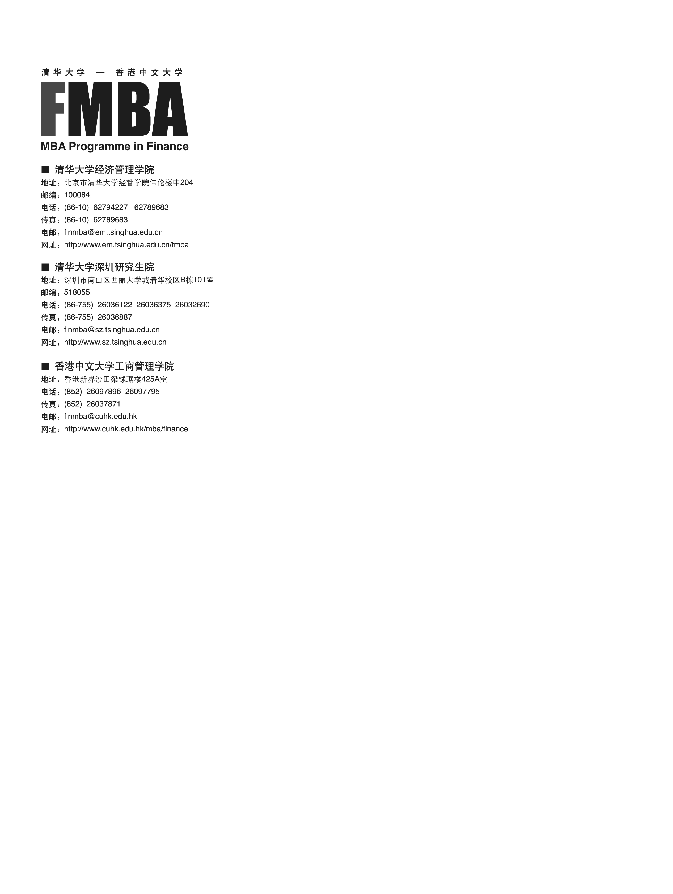


■ 清华大学经济管理学院
地址：北京市清华大学经管学院伟伦楼241室
邮编：100084
电话：(86-10) 62789683 62793962 62794227
电邮：finmba@sem.tsinghua.edu.cn
网址：http://www.sem.tsinghua.edu.cn/fmba

■ 清华大学深圳研究生院
地址：深圳市南山区西丽大学城清华校区B栋201室
邮编：518055
电话：(86-755) 26032690 26036876 26036954
传真：(86-755) 26036887
电邮：finmba@sz.tsinghua.edu.cn
网址：http://www.sz.tsinghua.edu.cn/

■ 香港中文大学商学院
地址：香港新界沙田泽祥街12号香港中文大学郑裕彤楼7楼743室
金融财务MBA办公室
电话：(852) 39437896 39437795 39435980
传真：(852) 26037871
电邮：finmba@cuhk.edu.hk
网址：http://www.bschool.cuhk.edu.hk/mbafin

